OBJECTIVES _Chapter 4: Section 4.3, Trigonometry Extended (Pages 331–339).
- Find the trigonometric functions of any angle, in degrees or in radians.
- Understand the periodic nature of the trig functions.
- Define the unit circle as having a center at the origin and a radius equal to one.
- Fill in the degrees, radians, and ordered pairs on the 16-Point Unit Circle.
- Use the unit circle as a schematic device.
- Use circular trigonometric to solve an expanded world of applications, which would be impossible with right triangle trigonometry.
- Use the unit circle (with a radius of 1 unit and a center at the origin) and any other circle of radius, r, to evaluate the 6 trigonometric functions for an angle when given a point on its terminal side.
- Use circular trigonometry to find the six trigonometric functions of an angle θ for which you know a point on the terminal side of angle θ.
- Understand that extending trigonometric functions beyond right triangle ratios of acute angles more aptly applies to real world situations where angular measures can be any number, either positive or negative.
Technology: Smart Board, graphing calculator (TI-83 or TI-84)
THE UNIT CIRCLE: A unit circle is a circle with a radius of one (a unit radius). In trigonometry, the unit circle is centered at the origin.
For the point (x, y) in Quadrant I, the lengths x and y become the legs of a right triangle whose hypotenuse is 1.
By the Pythagorean Theorem,
we have x² + y² = 1² or x² + y² = 1.

If we examine angle (in standard position)
in this unit circle, we can see that
which show us that in a unit circle,
also creating
Sine is represented by the vertical leg.
Cosine is represented by the horizontal leg.
Note that becomes

THE SIX TRIGONOMETRIC FUNCTIONS FOR ANGLES ON A UNIT CIRCLE:
sin θ = | csc θ =
cos θ = | sec θ =
tan θ = | cot θ =

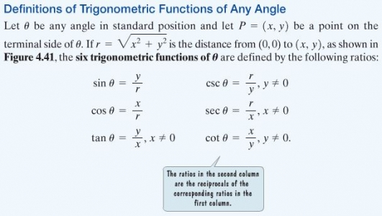
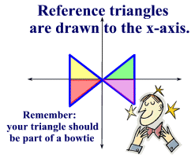A reference triangle is formed by "dropping" a perpendicular from the terminal ray of a standard position angle to the x-axis. Remember, it must be drawn to the x-axis.
Reference triangles are used to find trigonometric values for their standard position angles. They are of particular importance for standard position angles whose terminal sides reside in quadrants II, III and IV. A reference triangle contains a reference angle.
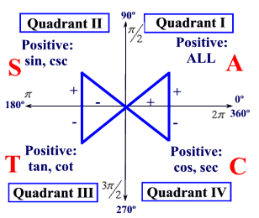
Fill in the table below, defining the Trigonometric Functions of Any Angle. See page 333, bottom of page.
Let θ be any angle in standard position, and let P(x, y) be any point on the terminal side of the angle. Let r denote the distance from P(x, y) to the origin.
That is, let r = √ (x² + y²). Then,
sin θ = | csc θ =
cos θ = | sec θ =
tan θ = | cot θ =

TUESDAY (4.22.25)
CLASS WORK/HOMEWORK:
- Review the trig functions of the special angles.

- Be able to fill in the degrees, radians, and ordered pairs for the special angles on a blank unit circle.
- Find the six trigonometric functions of an angle θ in standard position whose terminal side contains the point (-5, 3). Illustrate the situation.

- Study for the Quiz (Table of the Trig Functions of the Special Angles) to be taken during your next class period without using your notes or your calculator.
Write exact answers in good form.

THURSDAY 4.24.25)
- Discuss the work assigned previously:
Find the six trigonometric functions of an angle θ in standard position whose terminal side contains the point (-5, 3). Illustrate the situation.

- Quiz (Table of the Trig Functions of the Special Angles) without using your notes or your calculator. Write exact answers in good form.

- Class Work/Homework: Page 340, Exercises, #3 – 11, odds; #10. Give exact answers.)

FRIDAY (4.25.25)
- Discuss the work assigned previously: Page 340, Exercises, #3 – 11, odds; #10. Give exact answers

- Class Work/Homework:
Page 340, Exercises, #4 – 8, evens, and #12.
Page 340, #25 – 35, odds.

